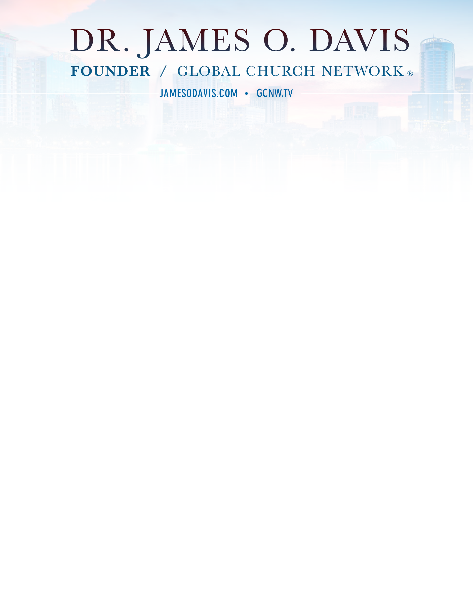

Dr. James O. Davis is the founder of Cutting Edge International and Global Church Network (GCNW.tv), a growing coalition of more than 2,650 Christian ministries and denominations from around the world who are synergizing and mobilizing their efforts to build a premier global community of pastors, to help finish the Great Commission by the 2000th Birthday of the Church (Finish2030.com). With more than 700,000 churches represented, the Global Church Network has become the largest pastors’ network in the world.
Christian leaders recognize Dr. Davis as one of the leading networkers in the Christian world. More than 80,000 pastors and leaders have attended his biennial pastors’ conference and leadership summits across the United States and in all major world regions. Dr. Davis has been named among the “Top Ten Christian Influencers in the World.”
From 1997 to 2000, Dr. Davis served on the Amsterdam 2000 Executive Committee with the late Dr. Billy Graham and the Billy Graham Evangelistic Association. Amsterdam 2000 hosted more than 11,000 leaders from 217 nations, provinces, and territories. The main focus of Amsterdam 2000 was to ascertain where the Gospel is not and to mobilize evangelistic leaders to help complete the Great Commission.
In October 2017, Dr. Davis spearheaded and hosted The Wittenberg 2017 Congress in Berlin, Germany. The Wittenberg 2017 Congress celebrated the 500th anniversary of Martin Luther nailing his 95 Theses on the Castle Church door in Wittenberg, Germany. This historic congress brought together more than 600 influential leaders from more than 80 denominations and every world region. Finish 2030 was launched at the gravesite of Martin Luther, the Protestant Reformer.
In September 2005, the Global Church Network launched the Billion Soul Initiative in Dallas, Texas. The overarching goal established was the planting of five million churches for a billion soul harvest in ten to fifteen years. In October and November 2017, GCN achieved the goals of one billion souls saved and five million new churches planted respectively.
Dr. Davis served twelve years as the National Evangelists Representative at the Assemblies of God world headquarters, leading 1,500 evangelists and training thousands of students for full-time evangelism. Ministering more than 45 weeks per year for the last forty years, Dr. Davis has now traveled over 10 million miles to minister face-to-face to millions of people in nearly 140 nations.
Dr. Davis earned a Doctorate in Ministry in Preaching at Trinity Evangelical Divinity School and two master’s degrees from the Assemblies of God Theological Seminary. As an author and editor, he has provided key resources to the Global Church, including:
- The Faith Book: The Master Key To A Grand Life Of Faith
- Living Life From A Heavenly Edge
- We Are the Church: The Untold Story of God’s Global Awakening (coauthored with Dr. Leonard Sweet)
- How to Make Your Net Work: Tying Relational Knots for Global Impact
- The Forgotten Baptism: Your Leadership Path to Fulfilling Your Vision (coauthored with Dr. Kenneth Ulmer)
- Scaling Your Everest: Lessons from Sir Edmund Hillary
- Gutenberg to Google: The Twenty Indispensable Laws of Communication
- The Great Commission Study Bible (coauthored with Dr. Ben Lerner)
- The Billion Soul Story
- 12 Big Ideas
- The Pastor’s Best Friend: The New Testament Evangelist
- Living Like Jesus
- The Preacher’s Summit
- What to Do When the Lights Go Out
- It’s a Miraculous Life!
- Signposts on the Road to Armageddon
- Beyond All Limits: The Synergistic Church for a Planet in Crisis (coauthored with Dr. Bill Bright)
His quotes and articles have appeared in scores of magazines, newspapers and blogs.
Dr. Davis resides in the Orlando area with his wife, Sheri, and daughters, Olivia and Priscilla. They have two children, Jennifer and James, who reside in heaven.

